Technical Datasheet Input / Output Modules with Modbus RTU Protocol with RS485 Interface

The IO modules communicate via RS485. The port can drive distances up to max 700 meters without the use of any repeater (this feature however also depends on the signal strength of the Modbus Master Device).
The RS485 Digital IO module is sturdy, low power usage and easy to use.

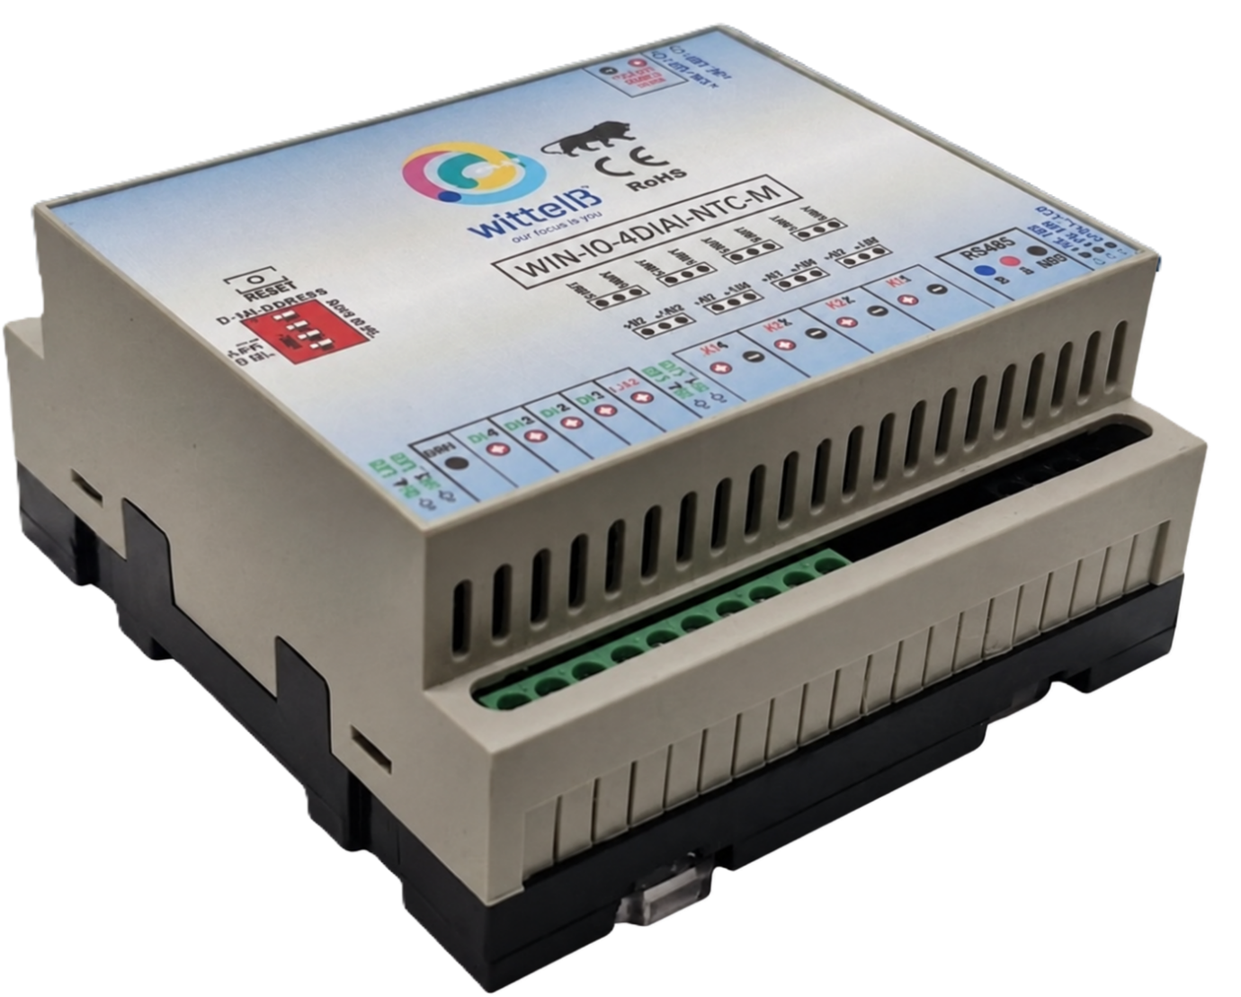
4 DI + 4 AI/NTC Module: -

The IO modules are mounted on DIN rail mountable casing and with exposed connectors and LED indicators. The DIP switch for Slave ID and Baud rate are placed inside the enclosure.

The design of the modules incorporates ‘resettable Fuses’ to safeguard against reverse polarity connection both for Power and Communication port.

Specifications
General –
I/O Connectors 14 Pin 5.08 mm pitch pluggable screw Terminal Block,
Dimensions 110 mm L x 110 mm B x 50 mm H
Power Input Power – 12 - 24 VDC or 24 V AC/DC
Typical – 12V DC @ 120mA
Operating Temperature 0 – 60° C (32 ~ 140°F)
Storage Temperature -20 - 70° C (-4 ~ 158°F)
Storage Humidity 5 ~ 95 % RH, non – Condensing

Certifications

DI Inputs –
Channels 4
Sense Voltage 3.3 – 30 VDC
Sense Logic Logic ‘0’ = <1 VDC, Logic ‘1’ = >3.3 VDC
Isolation Optically isolated
Response Time 2 msec, Max 6 msec

AI/NTC Inputs –
Channels 4
Input Signal 4 – 20 mA / 0 – 10VDC / NTC Type 3 (jumper selectable)
Accuracy ± 2% Full scale
Input Resolution 10 bits / 12 bits (Optional)
Isolation Optically Isolated
External Loop Voltage + 12 VDC min
AI input impedance 120Ω

Additional Features: -
All inputs and communication ports isolated
Input power reverse polarity safety
ESD Safety IEC 61000-4-2, ± 30KV contact, ± 30KV air
EFT IEC 61000-4-4, 50A (5/50ms)
750V isolation.
CRC Error check.
No configuration needed on the IO board
Configuration Settings: -
Communication Speed 9600 – 115200 (DIP SW selectable)
Data Bits 8
Parity None
Stop bit 1
CRC Yes
Slave ID Configurable with DIP Switch
Function code DI 0x02 Read discrete Input
DI Register Address 0,1,2,3.
Function Code AI 0x03 Read Holding Registers
AI Register Address 10 Bit - 2,3,4,5 / 12 Bit – 6,7,8,9.
ID | Function  Description | Register  Description | Modbus Function Code | Protocol | Data  Type
1 | DI 1(With & Without Potential) | 10001 | 0X02 | RS485 | 1 Bit Boolean
2 | DI 2(With & Without Potential) | 10002 | 0X02 | RS485 | 1 Bit Boolean
3 | DI 3(With & Without Potential) | 10003 | 0X02 | RS485 | 1 Bit Boolean
4 | DI 4(With & Without Potential) | 10004 | 0X02 | RS485 | 1 Bit Boolean
5 | AI 1 – 10 Bit | 40002 | 0X03 | RS485 | 16 Bit Unsigned int
6 | AI 2 – 10 Bit | 40003 | 0X03 | RS485 | 16 Bit Unsigned int
7 | AI 3 – 10 Bit | 40004 | 0X03 | RS485 | 16 Bit Unsigned int
8 | AI 4 – 10 Bit | 40005 | 0X03 | RS485 | 16 Bit Unsigned int
9 | Temperature1 | 40006 | 0x03 | RS485 | 16 Bit Unsigned int
10 | Temperature2 | 40007 | 0x03 | RS485 | 16 Bit Unsigned int
11 | Temperature3 | 40008 | 0x03 | RS485 | 16 Bit Unsigned int
12 | Temperature4 | 40009 | 0x03 | RS485 | 16 Bit Unsigned int

Note: -
For MODBUS communications, a shielded and twisted pair cable is used. One example of such cable is Belden 3105A.

Recommended Cable Electrical Characteristics: -
22 AWG Cable Shielded and twisted pair should be used.
Tinned Copper Recommended
Nominal Conductor DCR 14.7 ohm / 1000 ft
Nominal Capacitance 11 pf / feet (conductor to conductor)
High Frequency Non-Insertion Loss 0.5db / 100ft

DI

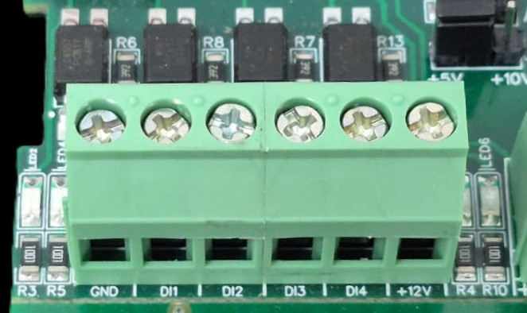
I/p device
I/p device
I/p device
I/p device

- Operation: The module provides four isolated input channels (DI1–DI4) for sensing external signals or dry contacts. These inputs are opto-isolated for circuit protection.
- Terminal Layout:
  - GND: Common Ground reference.
  - DI1 – DI4: Individual Digital Input channels.
  - +12V: Internal reference voltage for sourcing "Dry Contact" switches.
- Wiring Options:
  - Dry Contact: Connect a switch between the +12V terminal and any DI pin.
  - External Voltage: Connect the external signal to a DI pin and the external ground to the GND terminal.
- Voltage Rating: The input circuitry is rated for a maximum of 80VDC. Ensure external signals do not exceed this limit to prevent damage to the isolation ICs.

AI-NTC

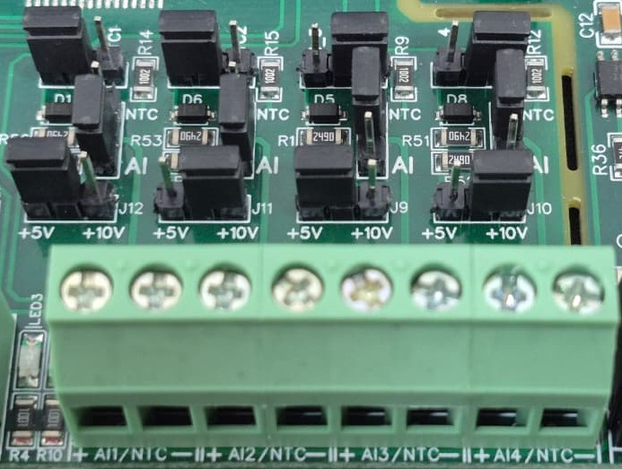
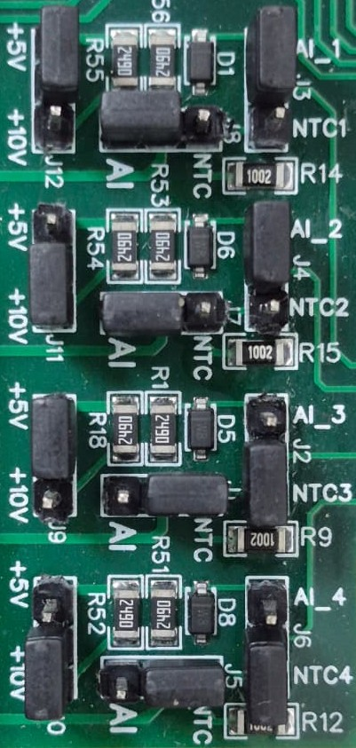
Sensor
Sensor
Sensor
Sensor

- Analog Input & NTC Operation: Each channel provides two terminals: + (Positive) and - (Negative/Common). These are used to interface with either standard external analog sensors or NTC thermistors.
- Channel Configuration (Visual Guide): Each of the four channels features two dedicated jumpers to independently select the operating mode (AI or NTC) and the reference voltage range (5V or 10V). Refer to the color-coded boxes in the board diagram to configure your desired scenario:
  - Red Box (AI Mode, 5V Range): Set the mode jumper to AI and the voltage jumper to +5V.
  - Green Box (AI Mode, 10V Range): Set the mode jumper to AI and the voltage jumper to +10V.
  - Blue Box (NTC Mode, 5V Range): Set the mode jumper to NTC and the voltage jumper to +5V.
  - Yellow Box (NTC Mode, 10V Range): Set the mode jumper to NTC and the voltage jumper to +10V.
- Sensor Wiring Connections:
  - The sensor or thermistor's positive signal wire should be connected to the + terminal of the desired channel (labelled AI1/NTC, AI2/NTC, etc.).
  - The sensor's common or ground wire should be connected to the corresponding - terminal.
- Crucial Setup Recommendation: Always ensure that both the mode jumper (NTC vs. AI) and the voltage jumper strictly match the hardware you are connecting. Incorrectly setting an NTC to an AI mode, or mismatching the voltage limits, will result in inaccurate temperature or signal readings.
SLAVE ID DESCRIPTION
MSB
LSB
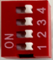

For Slave ID Selection SW is used to Set The SLAVE ID .
For Slave ID DIP Switch LSB is “1” follow through “4” is MSB.
Slave ID Confirmed through below Device ID table .
IF Eg. Slave ID 1 is Needed to be selected Switch number 1 should pulled up other three should be selected down side. So”1 0 0 0” will be selected as Slave ID 1.

Slave ID | DIP SWITCH |  |  |  | OUTPUT (Binary) | OUTPUT (Decimal)
Slave ID | 1 | 2 | 3 | 4 | OUTPUT (Binary) | OUTPUT (Decimal)
0 | OFF(0) | OFF(0) | OFF(0) | OFF(0) | 0 0 0 1 | 1
1 | ON(1) | OFF(0) | OFF(0) | OFF(0) | 0 0 0 1 | 1
2 | OFF(0) | ON(1) | OFF(0) | OFF(0) | 0 0 1 0 | 2
3 | ON(1) | ON(1) | OFF(0) | OFF(0) | 0 0 1 1 | 3
4 | OFF(0) | OFF(0) | ON(1) | OFF(0) | 0 1 0 0 | 4
5 | ON(1) | OFF(0) | ON(1) | OFF(0) | 0 1 0 1 | 5
6 | OFF(0) | ON(1) | ON(1) | OFF(0) | 0 1 1 0 | 6
7 | ON(1) | ON(1) | ON(1) | OFF(0) | 0 1 1 1 | 7
8 | OFF(0) | OFF(0) | OFF(0) | ON(1) | 1 0 0 0 | 8
9 | ON(1) | OFF(0) | OFF(0) | ON(1) | 1 0 0 1 | 9
10 | OFF(0) | ON(1) | OFF(0) | ON(1) | 1 0 1 0 | 10
11 | ON(1) | ON(1) | OFF(0) | ON(1) | 1 0 1 1 | 11
12 | OFF(0) | OFF(0) | ON(1) | ON(1) | 1 1 0 0 | 12
13 | ON(1) | OFF(0) | ON(1) | ON(1) | 1 1 0 1 | 13
14 | OFF(0) | ON(1) | ON(1) | ON(1) | 1 1 1 0 | 14
15 | ON(1) | ON(1) | ON(1) | ON(1) | 1 1 1 1 | 15

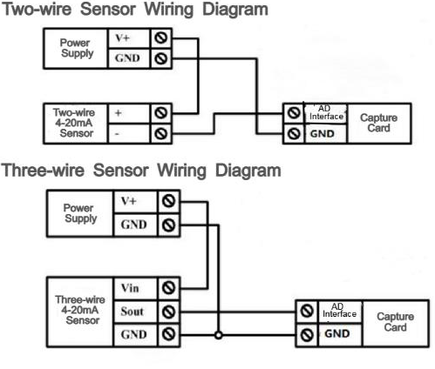
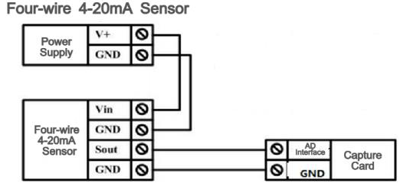
1 2 3 4
DI +ve Pins
AI AI2 AI3 AI4
Analog Input Pins
MSB
LSB
SLAVE ID
Modbus RS485
Input 12-24 VDC
Common GND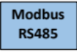D
+12 V DI Ref
5V / 10 V
AI Jumper
NTC
Jumper

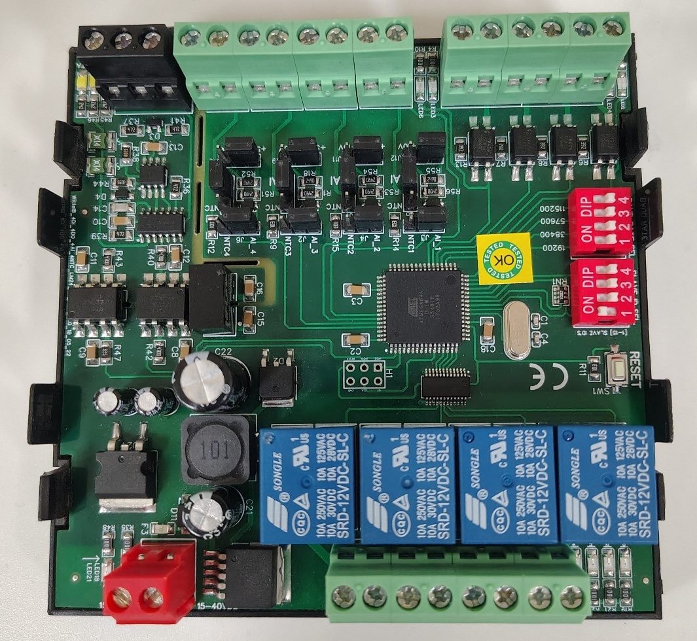
NTC
Jumper
MSB
BAUD RATE
LSB

Contact Information
Augmatic Technologies Pvt. Ltd.,
Plot no 6, Shah Industrial Estate II,
Kotambi,
Vadodara – 391510.
Email – Sales@wittelb.com
Support E.: support@wittelb.raiseaticket.com / M.: 9403892805

